Guts of a Tree

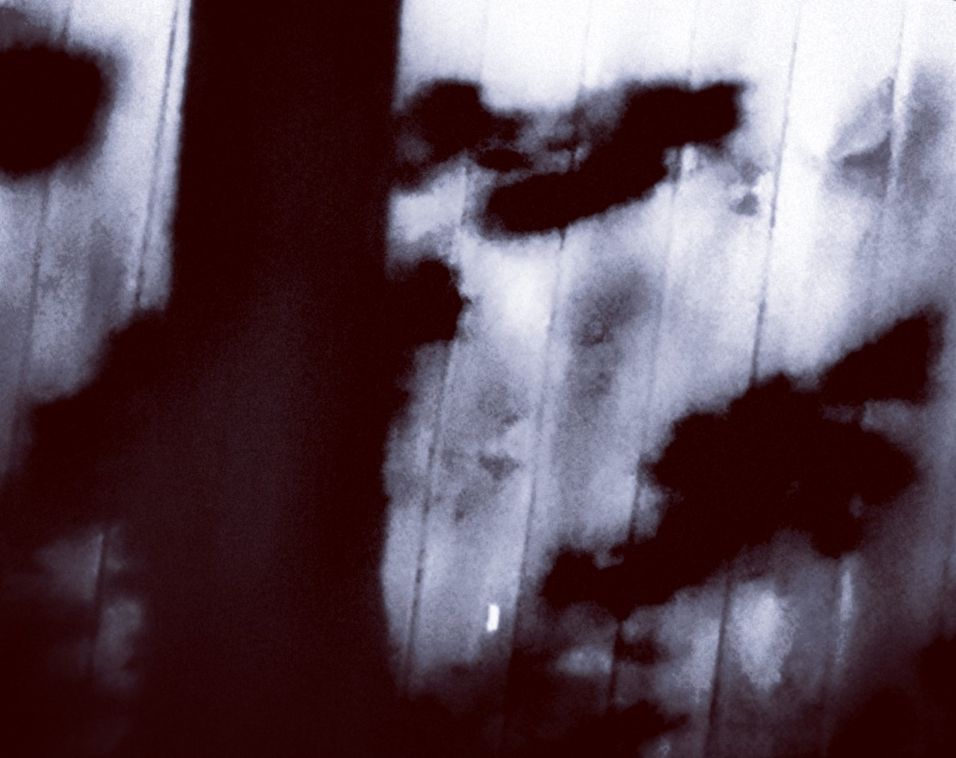

Conceived and Proposed
By: NoT Me

Part I

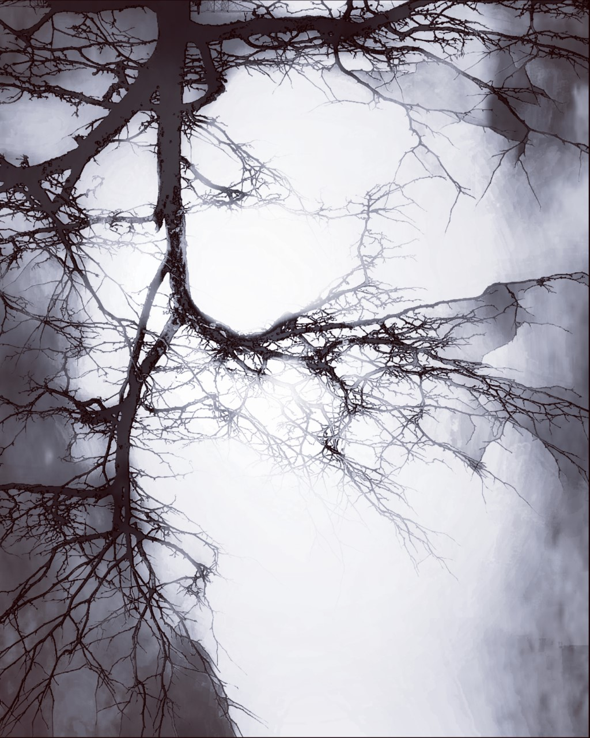

frost in a
heap
of..

nobody leaves
before sun
nods-

maple longs
to drip
sap

over fresh cut
grass

through pores
clogged.

can’t thaw all
at once

unloved, shouting
happy endings
at T.V.
hard it's
felt
by lovers on
lonely
side
of paper
walls.

crumbs of
clues-

should never
bait me
home,

you thought
better
of

me-

in glow
of your room,
in the
shadows too.

mutable
spark,
jewel kept
dirty
whispers
under
dust

hanging in
slow
air
blown in to
thaw
us,

no breath
to spare.

jotting words-
scars of desires
expired
in sober
haze,
spotting birds-
dots over
eyes

distant words.

calm cripples
valley

in
mourning,
chest poked
by fears
of fallen
mouth,

eyes retire to crest
of dawn
moon

faded blue,

knowing
you'll
be

shipped
out

soon.

green tea
tastes
lemon wedged
in teeth,
no sweeter cut with
sugar and
cream,
espresso slow
trickling,
last brain cell
brewing
not
adjusting
valves
hiss
bitter genie
from a
cup
too eager to
grant,
don’t wake
me up.

forwent house
to go home,
pleased no one’s
there,
no landmines,
no shut
outs-
nobody
cares,
soon fled that
home
too,
for brighter
spot to
rest
my bricks
upon
you.

prudence fades
to corner
keys,
cravings too
deep

to say
for fingers taught
in fear,
what may she
play me
no more
today,
my dear.

plain girl
magic,
no fadeout
of ballad,
skyline’s bloody
dark to tell
if blurs
are
ghosts at
dusk,
or lovers wading
past the
drop
off,
eyeing us.

may you slumber
like a slab of
comfort
lost in squall of
feathers,
a kiss upon day’s
pillow
unsticking
lids-

cold snaps
again.

your funk, like fresh
licked fingers

painting smiles
day seldom
holds,

holes,
just holes-

capped in
gold.

polyphonic
traffic,

moody
layered lyrics

through the
wires

flushing sediment

broadcast’s
fuzz in
wall-

grind on
bone’s

fantastic wash
of static,

not
a habit.

pirouetta,

cross eyed
bella,

unmoved by
my dance,

still
demanding
entertainment,

spin the stage
and

face the lights
this once

silent caller-

hung on
you-

sleeving
sighs

through dark
ages

to question
mark

the permanence
of periods,

are we
safe

to share in
secret?

a naked grape
night

in gloom's
gown

no more
advice

these are
your

orders,

there's the
door-

if you
like,

or, come
closer.

a fleck of
magic

few spades
seed,

less
growers see

sharing such
stirs
up

shames hushed

by pulse takers,
pinch cheek
gropers-

grooming us to care?
when raised,

my hands
too

have scared.

recent, and most
lonely-

i fear words
serve

whims of
pride-

broadcasted
clearer
than

receptor might
expect,

born into self
deceit

blindfolded
and

erect.

sofa has
lips,

we shift,

downstairs pancake
flips,

unnoticed,

i turn from teases of
miss teevee-

in quicksand
screen

clutching throw
another toss
away

wishes to
be

known but
not

seen.

of amor’s fever
magnified

themes uniting
internal-

eternity, a petal
shines thru
metal,

blush, peek
a boo

headlights
dim-

a twitch in
nerve

of dead
end.

integrity won’t
trophy

golden
goods about
common grounds

in fits
of grandeur-

daddy’s least regarded,
guarding
time

like sinking
treasure.

shames turn
iris shy
to

her own
light

no escape from
the high-

fretting, fact drunk
and faded,

in wait for
truth
to

strip my
eyes.

fall, when hope’s
no rescue-

consumed and
subdued

in absence of
chatter,

inch a hair
closer

to match ring
moods,

i curtsy, stranger
adorned by
you.

may it be
said?

meant is each
shift

and squeak upon
hot seat

don't lean in
unless
able
to

love all you
see-

even me.

no
wreck

deserving of
neglect,

whether from uranus
mars or star
orbiting
venus-

a new mom hates
her vulva
while

mid-aged dad
wants a
penis.

Part II

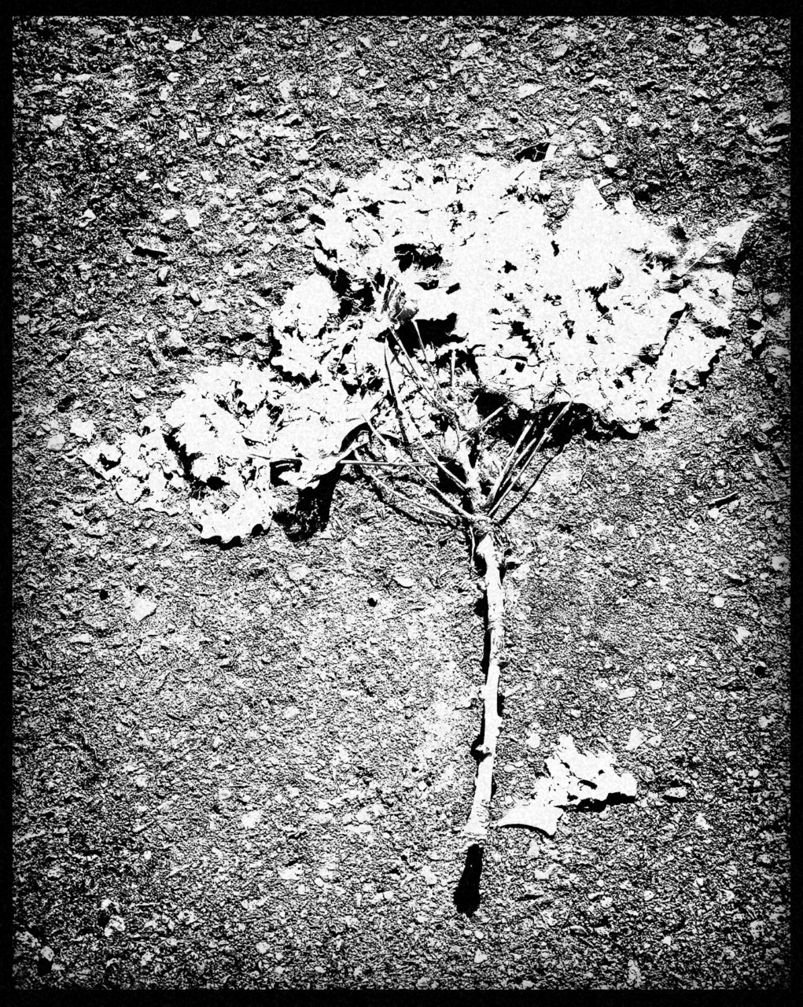

ailing maple
no longer
yields

from the
heart,

no sweetness
kissed
into

pail hung
over

stake in
bark.

pretty cute-

never the keeper,
make me
pay

out vestal
eyes

not
your
ransom,

don’t call me
pretty
cute,

under shadow
of your
boot.

edge is
time

dragging past
to pause

easing wear
on sole-

filing down
claws,

no chewing
paws,

no drawing
blood

to lick it
raw.

loyal liar to
the end

mask on fire,
seldom

warming
hearth,

it’s heavy for
a june
night-

not quite blue,
drapes

bled off
white.

let's write new
sitcom,

not a major
network
one,

want laughs
loud

or we’ll miss
them,

while too proud
to listen.

in wake of
farewell,

smiles meant
toothbrush
rests

ever untouched-
on scarcer
night-

incomplete

and too
much.

drags dying guitar
to unborn
tune

picks til day
song’s
dry-

stripping
strings

in ode
to bleached sky.

downpour of
doves

over sheet
metal
sea-

circling coast of
shimmer

beach branch
bending

to grace fingers
beyond
reach.

mocking of my
stutter’s

she who blew me
butterflies,

roach too cozy
in crack,

nesting over
gutters

moths up
and

down my
back,

calling for
mother.

passions pregnant-
we step
out

on day’s fuck it
list of
debt-

date night
heels

dig into
back

nails caressing
knots from
neck
in

collapse.

pass me
knife

and melt
butter,

mind drifts-
bit lip,

a hollow
tear,

sun rises for
paris

as i hold
here.

howling in
winter,

where you been
huddling?

the icicles
drip-

tips
inviting,

barefoot in
puddle’s
slick,

don’t slip,
just a warning.

can casual
highs

satisfy men made
at sit downs?

crack snipers through
peepholes

in badge heavy
towns-

confessions of
mole man

turned cell
block

clown.

not
wrong

though i
say,

to shovel shit
over graves,

both slept here
before-

we only
shrug
or

war.

surround sound hearing,
diminished
dread
of

diagnoses-

promise me
no prick

for
relief?

and i’ll vow
to smile

with more
teeth.

only believed when
agreed,

splitting as
chain,

relieved until
reel’s end-

only to sink,
within

and watch it
again.

the breath of
clean,

lungs can’t
receive

like staring
at stars,

with toes in
weeds-

we
breathe.

.

no nemeses
only me-

shrunken
soul-

white knuckles
control.

here’s a friend,
just me,

all me-

til crash landing
of dream

mouthless
screams.

coarse to skin
like touch,

mush beneath
ragged
peel,

send your
snakes

down trunk
to report
back
on

ills roots
reveal.

Part III

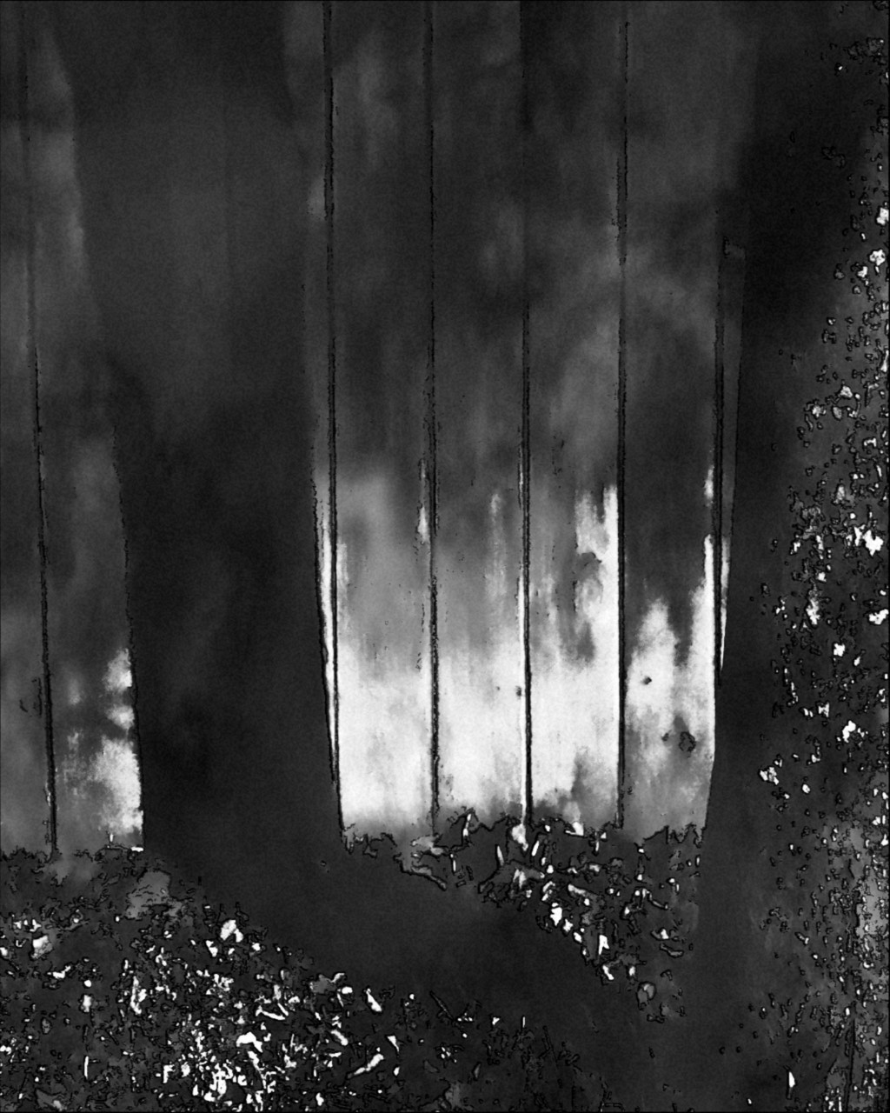

in
serenade,

i've
deceived,

but hold this
kiss true,

took breaking
on guitar-

to
learn

i’m pianist
in blue.

heart’s echo
denied

hands on
neck-

a sorry
need,

when threats
of feeling
melt

away our
heat-

are you here?
will we ever
meet?

city
dreamer,

sneak the wheel
from me,

cabs look more
black than
gold
in

a sea,

nameless in
bunch,

happy
late for lunch.

escape
rung,

an inch from
doubt

it’s dark for
the time

of DNA
test,

i rather

kneel
in protest,

hands over
heart-

even for the
hour

it’s dark.

a charmless tipsy,
tap me
out
of

dance
off-

in stretch dress
i plead

standing
on polished feet,

slowing spin’s
pace

collapsed in
hands
to

hide my
face.

busy, she’s a
beauty-

bar-tap queen
in faded
fleece

dreaming
green,

down and gritty-
duties
of
a

mudflap
girl,

earning fairer,
brighter
shot
at

world.

flooded over,
so over,

fails to drown
his cup

loyal to
the

last drop,

to get
him
up-

or not.

saw truth
seeker

had no time to
find me
back,

watched a rainbow
born of hell’s
asshole-

there’s no
unseeing that.

softly strokes
fine hour

to extract
magic

from habits
spinning
smoke

into forms
drawn

back into wand
to throw
violets
upon.

promise for the
ageless

no wilted
woe.

no breaks
or go,

heart, rain sun
to flower
wise

deep roots
grown

restless
eyes.

where distaste
for life is
born

time’s a
tomb,

and that
reclaimed

for own knowing
reasons

reseeds in
womb

for turn of
season.

may moon
drop off
and

day wake to
none,

dust won’t shake
from blinds

‘til
credits run

from screen
streaking
walls,

may we say
little

and feel
it all.

swatting fireflies of
lacking sunrise

a thrift-store
painting,

hung over
couch

built for dreaming
life under
mulch.

host surveys
shadows-

company
fades,

peace of land
in hand,

steady ground
regained

strike any gong,
after eight

room cheers,
proud

to
castrate,

ring a bell,
and
all

eyes
salivate.

below
you

tulips go
blue-

pursed to shiver
unto death,

under thumb
i fight for
air,

then rise

to brush dust
from hair.

don't need it
to let go,

gone and wise
to know

where chains
scarred-

grass still
grows,

not under
snow

never last
chance

‘less chest’s
buried

where past can’t
reach knees-

to drag us
back,

into play of
masks,

we don’t
speak.

vintage
strips

on blushing
tongue,

3 sips in,
all ends numb..

suck sounds
the hard
way

down, to find
heat

underground.

scotch mint
lips-

stings upon
pink-

please and
desist-

cinnamon
heart
eyes

blown
out
in
a

kiss.

can't hunt what
chases,

take it off,
lay low,

tease your
taste
is..

track me,
if you

lock my
focus,

break me from
the crowd

take us
where unallowed.

agreed, not
ready

to let go, plot
unveils

peering
into

pores
of misery

shedding gold
on blue lip
bounty

to
bury

beauty in
pain’s

waking
wet

having felt
no rain.

a quivering of
creases,

blurring lips
on land

cleared by winds,
away with
dream's
sand-

lend me trust
only

drowning,

not
damned.

pleas find
eyes,

where brown
grounds
sky

keeps the sea
from

turning
tide.

truth spell
cast

for truant
class-

projector whirs
clicking-

power point
gets stiff
reboot,

slow to update-

apps crash
i laugh-

as preyers
preach

more telling
than any
joke

policed by
speech.

full past won’t
flush,

we
shrug
goodbye,

just not eye
to eye-

hurts too
much.

mess of masks
on tissue
paper

weight of
each

eroding
spine,

a mind full of
moods

none mine.

if freed all
duties,

would we
dance?

never swayed
without

a reason in
unison

can’t help
but

crave closer,
if only

for
closure,

if
not
forever.

no
regrets,

only here to
risk,

i care not
collect,

pleased with
my pot
and

settled scores,
behind

deadbolt
door,

pity by the
pages to
send,

i’d rather
pen

brimming with
soul to
say,

otherwise-

words of whining
boulder..

bridges to well
wishes-

too late, to
unread

upon the
page-

guts of a
tree.

