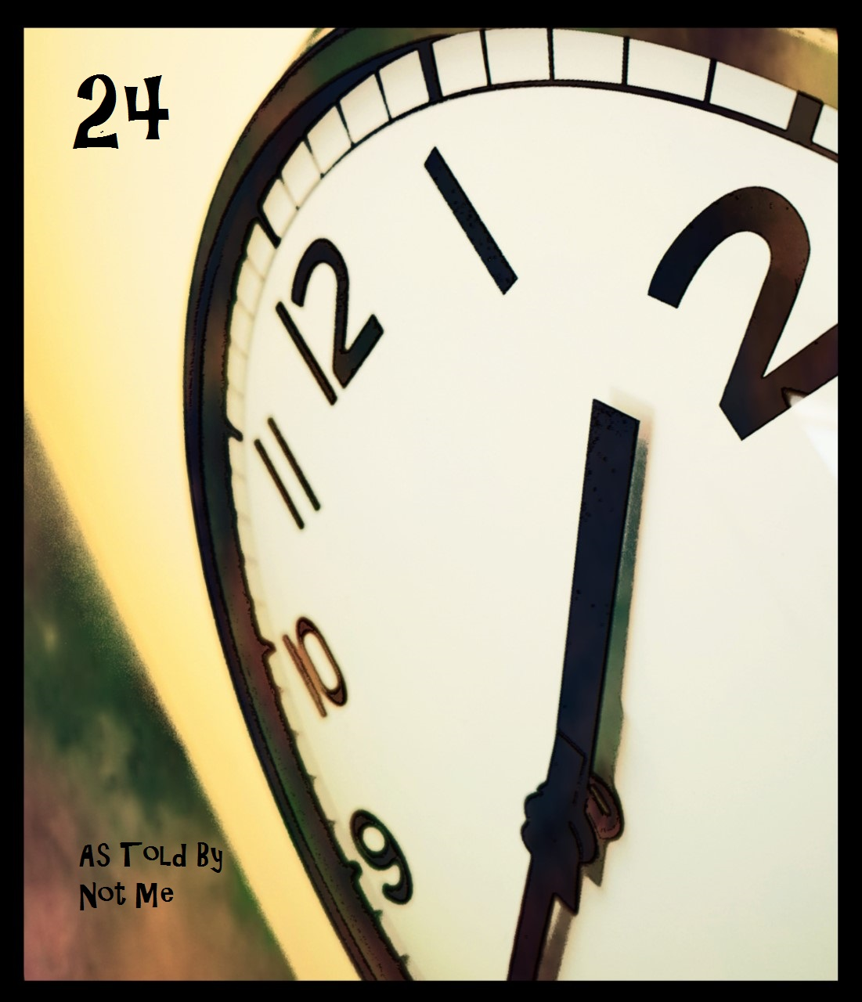



the hour of
day-

minutes in
my way
to

calendar
space

has little
say,

as countdown
nears zero,

faith in self
strays
to

heroes for
pay.

0:00–1:00..

sound off, safe
alarm,

sweats wakes
me every
time,

made crash
site a rest
stop,

rolling up to
squad
car

at red
eye

holding dead
space,

blades of
floor
fan

click
inches from
face,

cool but flat
in easy
pose

to
let go.

..1:00-2:00..

silhouette
stretched too tall,

sees not laces
for the
boot,

or all they
level

under
step,

hunching over
rubble's

boy troubled
little

by
neglect.

..2:00-3:00..

smoke folk
gaze

at diamond
dancer

striding railing
drowning
urge

to
dive

into sea of
eyes

swallows
lives.

..3:00-4:00..

rounding
loop,

balding tread
every
lap

through
blur,

to patch of
grass-

mirage made
real..

not to
last

past my
turn.

..4:00-5:00..

again,

i’ll condone
poem’s

faux playful
tone,

then shovel
on more
bones,

baked in hell
of flame

to
fake,

a chain of
words

around the
world

to test their
point
of

break.

..5:00-6:00..

shall we play
make
up?

may I man the
lipstick?

traced in
quiet

smudged
like

movie blood,

showtime’s
all we’ve
got

til capes and
masks

peel back
to

dress up
box.

..6:00-7:00..

rattles in wind
tunnels

fate upon tip of
a match

threading boarders
through cracks,

time would not
patch,

on
boxcar

we’d
nearly catch.

..7:00-8:00..

by
lazy
ember,

fanned in dark
hour lesson-

mourning
dead
wick

looks
desperate

in
reflection.

..8:00-9:00..

morning crawl
drags

nails scraping
bone,

what's not sun
is done,

can't un-fire
a gun,

won’t say it
wasn’t
fun.

..9:00-10:00..

forming tighter
bonds with
songs

than
singers,

a lone way
to be,

when heart
pounds

thru etheric
bleed.

..10:00-11:00..

nothing feeling
grows

deeper the
fear
of

fulfilling,

not
encouraging,

barely
probing it,

feel something
gnawing

where there’s
gold-

and want
all of
it

..11:00-12:00..

garden slug,
smothered snug,

won't find eyes
to shower

downcast
head,

at sunken
end of
bed,

find
us

doves on fire,
circling
nest.

..12:00-13:00..

breathless,
desire
dies,

chugging
humble
pie,

half
baked,

assume it
tasted
fake,

never caught
dream
but

woke-

to brighter side
of screen,

wash doubts
down

with lemonade,
and if you
miss
me,

make it
pink

but not too
sweet

to
drink.

..13:00-14:00..

tide
made
smoother,

by letting
worst
pass,

palms stitched
to side,

rather fly to
shady side
of isle

than lay
claim

to
you

thru
dead eyes.

..14:00-15:00..

frosted
lake,

swan on blunted
blades

snag
first bump

hands flattened,
flailing

for
railing

to distract from
aches

of
stage
breaking.

..15:00-16:00..

two steps skyward

one down
slip,

choo-choo
clock

clickity clack,
through
holy

teeth chatter
along

fork out
of

town, far
from

beds
left brown.

..16:00-17:00..

remastered
noise,

a marinade in
minor
key-

sticky dream
of prom
night’s

wasted teen-
on the
hunt

for match and
kerosene.

..17:00-18:00..

love won’t
loathe

for all its
loss,

drunk spender
frets no
cost,

on my own
now,

can't feel
held by
frost.

..18:00-19:00..

find change behind
my ear?

spend it
all

or drop it
here

gold grows
from

the gut to be
given,

not boiled
down

to legal
tips

aimed thru
teeth

of Hunter
Hard

to hear any
plea

not his.

..19:00-20:00..

a whole
made

misshapen
pieces,

no more puzzles
please,

no surprise
to find

a penned on
smile

no
less
fetching

to my
eye.

..20:00-21:00..

hollow pleasures,
buried in
you-

woodpecker
hammers

where bark bruises
bluest

jewels on
vine

brimming
cup,

heels in
mud,

don’t raise mast to
my winds

heard it brings
hard luck,

just give it
time

to sink
in.

..21:00-22:00..

breath
of slumber

float me
to sea

in gutted
skull-

brushed
rust

proof coat,
restokes

the dream
in trust

fire of one’s
enough.

..22:00-23:00...

maestro bound
starborn
kid-

to feed eyes
spilling

over lips to
drink,

parading him
as clown,

poking
wounded wing..

makes birdy
sing

grounded song,
not long
for..

dawn’s
shadow cast-

last stage
hound
out

finds maestro
left for
dead

webbed in puppet
thread.

..23:00-0:00

night shifter
returns
with

shovel, mop
and pail,

to
sop
runoff,

and bury the
rest
if

such fails.

~***~

twenty-four and
no more,

hobbling into shadows
is last acting
hero

three- two- one
zero.

. 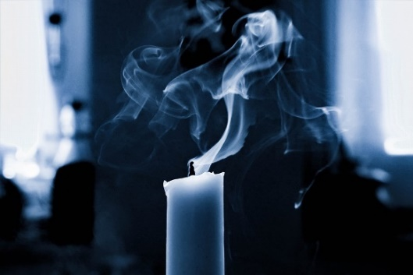

open sign: Pexels
blown out candle: Robin_S
(pixabay)

Thank You

