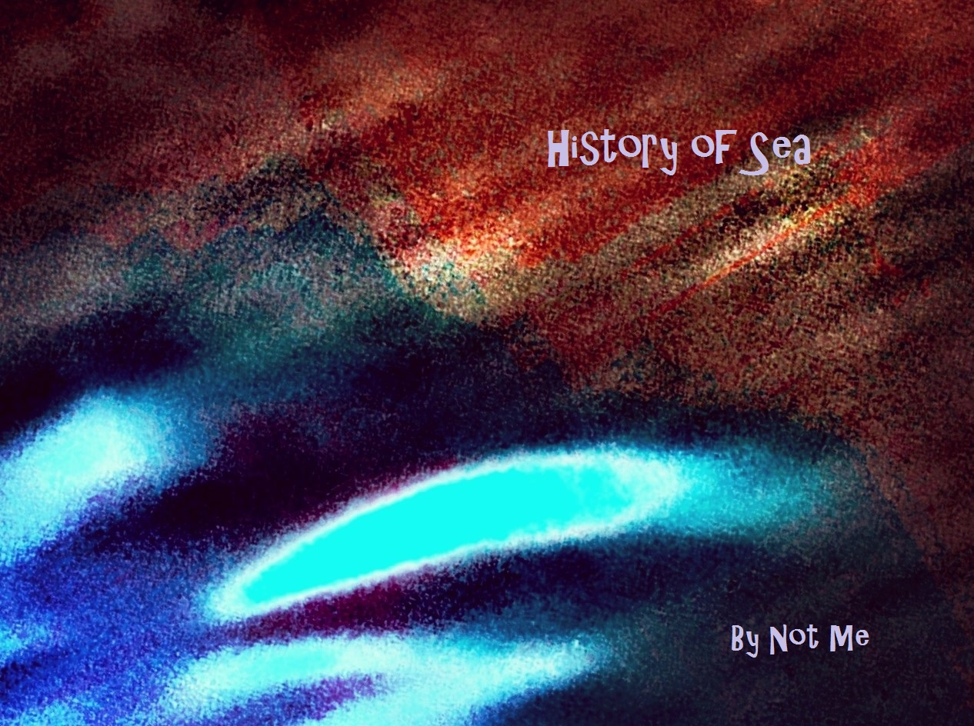

tonight broke
water

flyboy

born
holding swatter,

all pathways
down the
same

no drain calls
this fresh
rain,

history of
sea

through
growing pains

just more guts
on the
page.

First Wave

stunned
in..

shake off
cuffs,

dig me
out
of

mosh pit
rush-

from pail on
beach

to chessboard
square-

watching end
days last,

from empty
chair.

crossing
double lines-

like heaven’s
mine,

re-folding
words,

no sleeping where
it hurts,

our worst
left

behind the
church.

how should
a wave

know
another

cast in mirrored
glaze?

does head cold
know

he’s in the
way?

doesn’t winter
know

she’s
overstayed?

prick
in groove

a misty pane
mood-

moon man
arched
over

sounding
board-

skips in
restless play,

not unlike
today.

truth cupped in
a cough,

all exits lead
to lost..

years over
words
of

no real
cost,

all
exhaust.

distraction, double
edged-

sweet dulls upon
the shelf,

a jar
forgotten,

filled
with self.

saved for
what?

i
quit

not
hungry

let it
sit.

eyes on
the..

do you
see

waking
to night?

eyes on
the..

i caught
home
sick

set fire to
skies

eyes on
the..

birds.

my thanks thrown
on shore

embracing
pain

of
kisses,

but not the
knives

blunted in
dance

to
survive.

no daylight
under
rock

cocksure,

but not serial
crook-

just shaded in
spots,

brags ad
man

sold on life
lost,

all dirt under
the rock.

morning muds
mirror-

weather veins
exposed

sudsy body
hot,

under
coat
of

ashes won’t
rinse,

a morning
cough

can’t
be missed.

too
much

come at
once-

relief
denied

in
churns..

pepto on
tap

heard last
call

still, a thirst
burns.

indulging erections
reductive

of
cells
engorged,

hot poker
calling

foul
defence,

hose down home
fires,

imposing as
inspired,

cold fish
when undesired,

in floodwater
seeking
higher.

Second Wave

yellow pages
erased

from shoreline’s
face,

the history
of sea

map font too
small-

hands, denim
deep-

time salts
rinsed,

no release from
screams..

just more
sea.

golden grand
are dawns

willing to carry
wood

to cabin stove
starved for
spark,

half
woken,

one hand in
icebox,

the
other
crossing heart.

song of no
words-

rings true for
birds,

don’t need
each

note
spelled out,

song of no
words

lost on
me

but not the
birds

are free.

stripped tracks
lead

down gutted
valley

guarded by
trees

stop over
night-

and hear train
whistle
thru

my
knees.

took a ring
in grief

and blood flow
ceased-

was sure time
would

kindle heart,

missing in
arms-

burning off
the dark.

never
old

salt and rusty
tips,

limping into
climax,

too young to
hide from
sun,

to
reflect,

too hot for
fun.

heard
nothing

but something
burst,

tipped
off
by

love
burning

up a beach of
thirst.

felt it
all,

then
nothing,

which lie's
worse?

past’s voice by
waves,

i turn from
shore,

to face the
wild-

between last
stand

and exile.

view from
a tree,

where garden
meets
sea

lend
a wave

should your
thoughts

be fond
ones,

or chase
me
to

the
bottom.

Final Wave

at foot of
hall’s

the
fire suite,

wherein flies
swarm

to
hush
regrets-

mud wrestling
death,

in debt
to..

wine stains
spread.

three words
in need-

bobbing..

carrot wrapped
on silver
dish,

not quite
filling,

too
wanting

to
taste
it,

no thanks,
i wait

three words
in need,

want real
gold?

shovel the
hole,

plant some
seed,

don’t do what
you’re
told.

ingrown layer
itched

in deep with
words,

kill the candle

cut
its wick-

fanning fumes,
that

left home
sick.

dusk in your
smile,

behind the
vines,

thirty-nine,

and yet
the

threat
of

eyes on
mine

paints my
face

summer
wine.

a fistful of
horse
pills

when race
begs
it,

but don’t
come
yet..

just
teases,

show-horse
down,

no
pistol
wakes him,

lost the
heat

had his
fun-

no cheater
wins

just
competes.

chased sunset
slow,

and rolled up late
for show

waste, my lone
regret,

sky
downed

by
own
weight?

did i
detonate?

was it
for best?

what's
left?

only
imagination

placed me in your
painting-

crouched by
fresh

autograph,

blended
rough

with
detail,

yet
unsold,

just being
part..

takes its
toll-

makes merely
being

worth its
gold.

blew her pink
vapors

into an inhaler
holding

for the
high

fresh
out
of

the
shaker,

towel dry
and

drop it all
for

my fever

for
your
pleasure.

we play
out,

with skins
off

steeped in
dead
sea,

no, never
me..

should
gods
ask

who
holds the
mask.

storyteller
never
left

the
porch,

knew home
flag's

every
crease,

cranking the
breeze

kept it in
ripples

when curses
crippled
crops

through needy
season
for

nature’s
dirty reasons.

steel foot
brain..

reckless rumblings
uncontained,

life owed to
fireflies,

and
watchers
rattling chains
to wake

tourist
train

lost
on the
moon again.

rose bush takes
up bed-

rot rinsed
from

sinuses,

oft thought
flowers
trite,

then picked
one

by
candlelight

seen both
sides

of
night

through hailstorm-
dishrag
sails

til
morn.

^{washed} out
eyes

through veils
torn.

sorry the moment
found
me

blue
hearted,

won’t deny
weather’s claims

settling truths
untold-

sediment on
ocean
bed

gone cold.

